Four tasks of backend:

1. Create Data
2. Read Data
3. Update Data
4. Delete Data

These operations are called CRUD operations.

Three parts of backend:

1. Server
2. API
3. Database

The job of backend is to work with the database.

Node.js: It is JS runtime env. It is used to run JavaScript on your device rather than running it on the browser.

Creating a node package:



This is created:

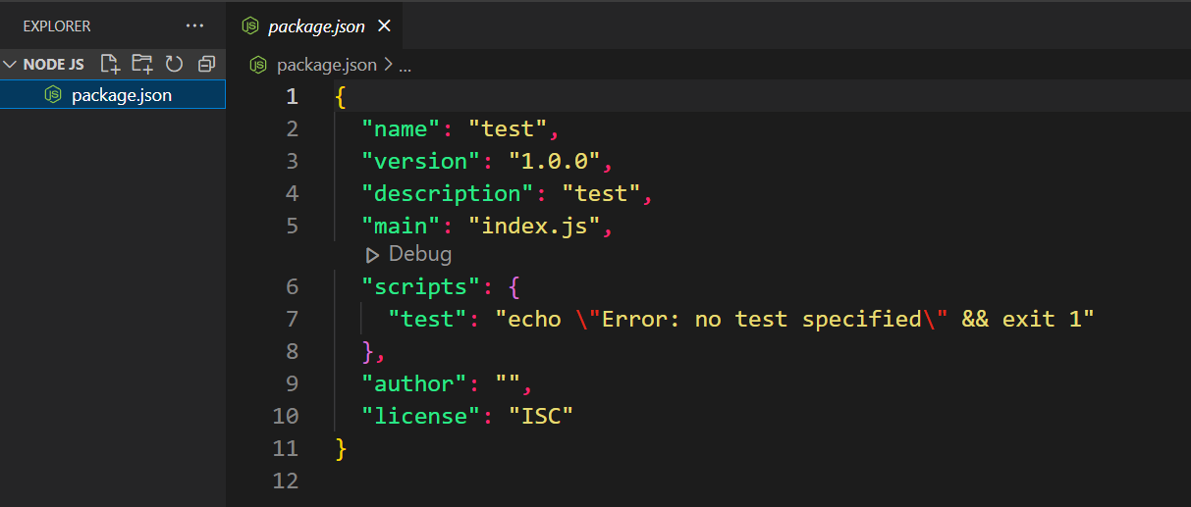

Package.json file has the details about the package.

It is a node package.

Let’s create index.js

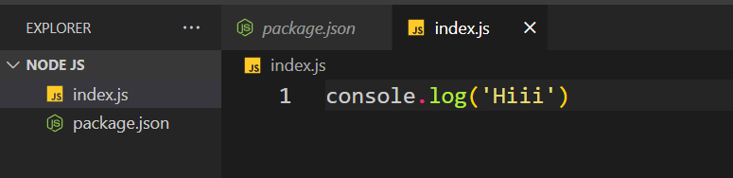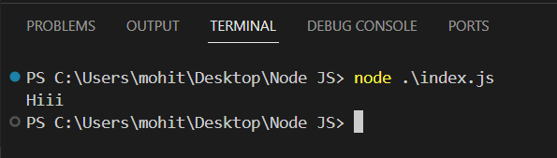

If we want to run the package as soon as we save it, we need to install nodemon package.



Run the js file using nodemon:

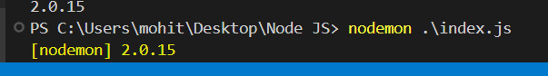

Server in node:

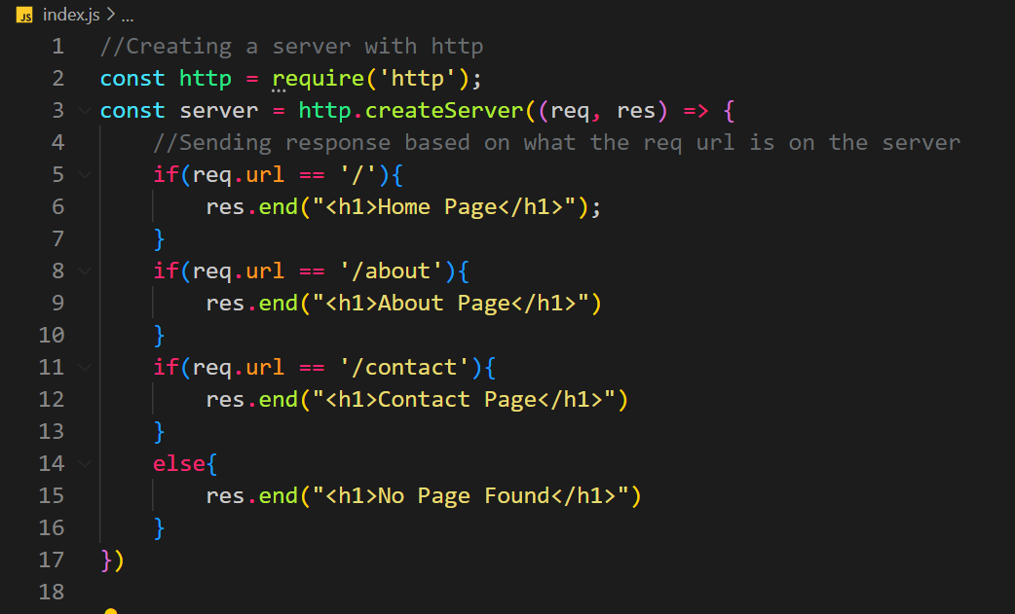

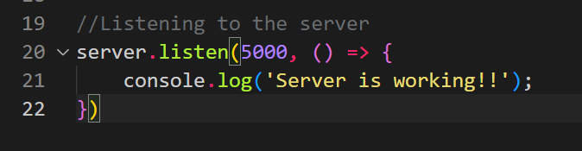

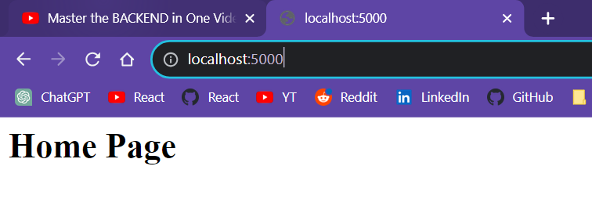

Modules:

Everything in Node.js is a module. Express, nodemon etc are all modules.

Modules are same as packages.

You can create a js file and have some variables and functions in that file. You can then export then and import them in some other file.

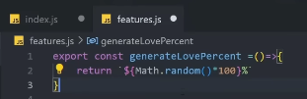

http, fs, express, os, they are all modules.

Methods: Get, Post, Put, Delete

Express:

Install: npm i express or npm install express

Creating and listening to a server:

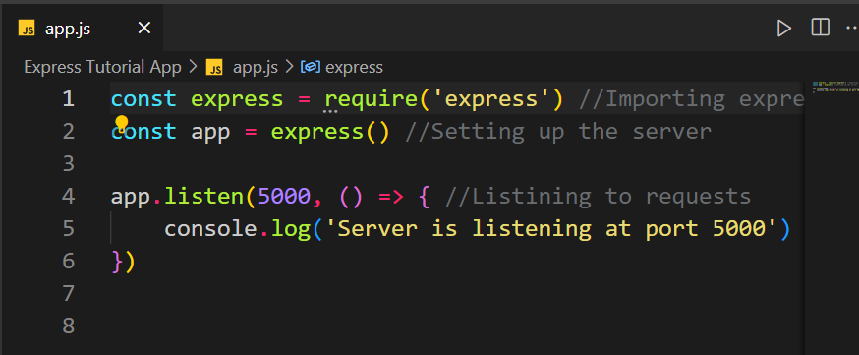

Starting the app:

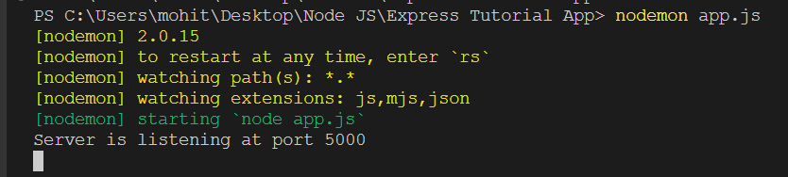

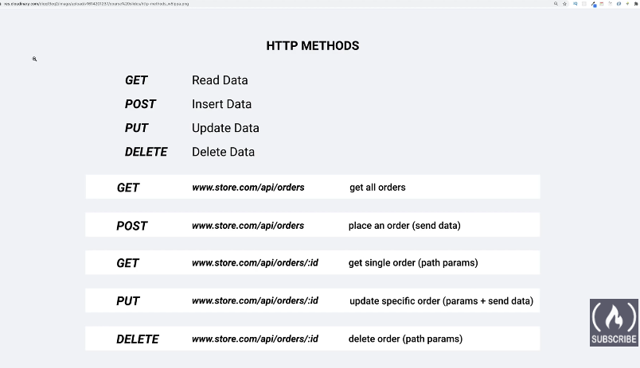

Get Method:

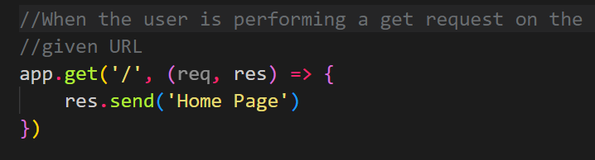

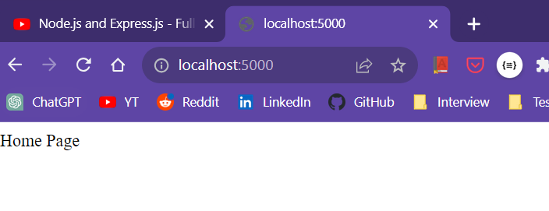

Routes:

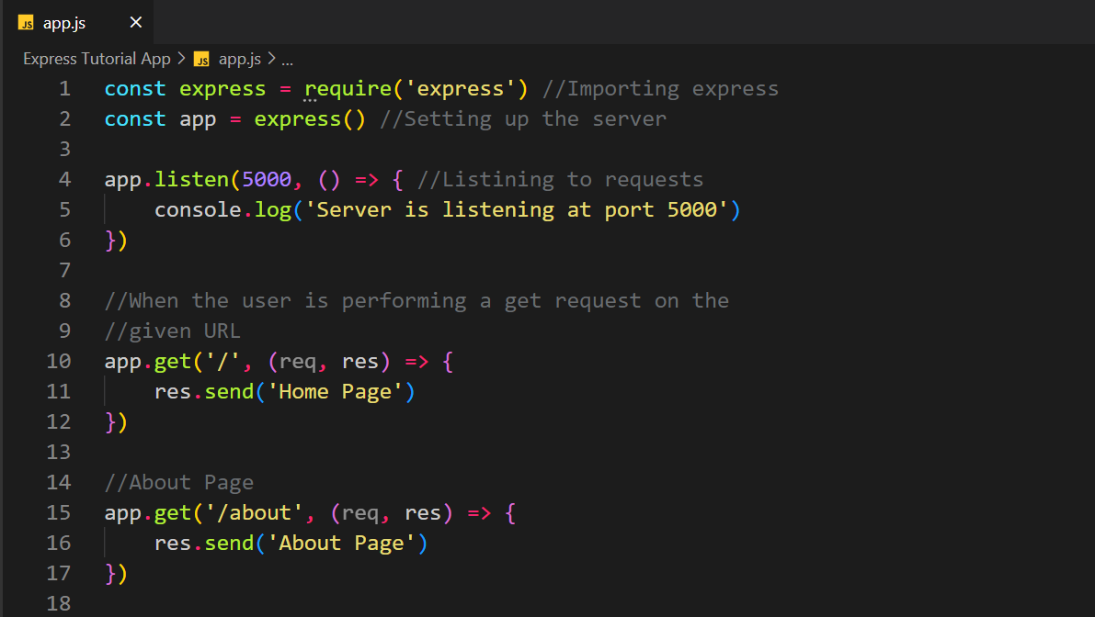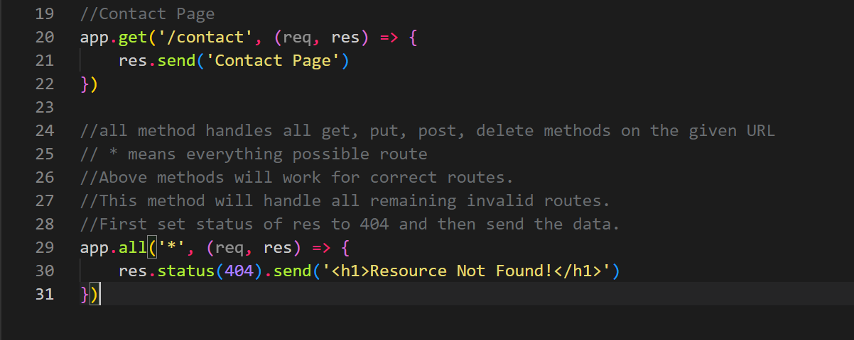

Sending HTML file in get req:

